Scenario 1: DBS Investment

1. Draw a business process flow diagram to illustrate John’s existing processes.

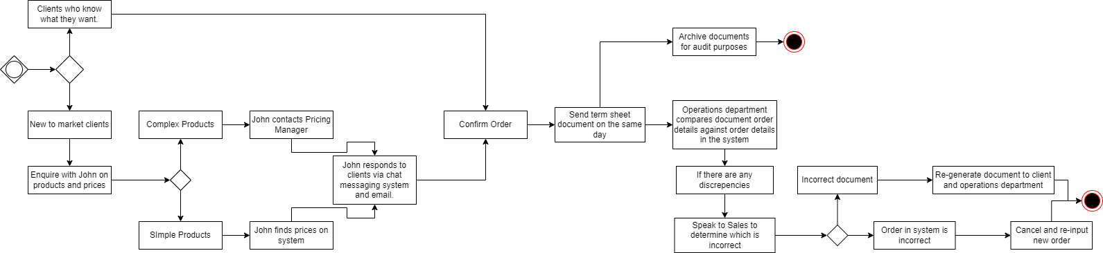

Scenario 2: Enviro 365 Bank

1. Step 1: I would identify who the stakeholders are that would potentially be required during all the phases of the project. This would be an extensive list to ensure that no important stakeholders are missed.

Step 2: In this step I would group the stakeholders according to the following power/interest grid:

* 1. High power, High interest.
  2. High power, Low interest
  3. Low power, High interest
  4. Low power, Low interest

Scenario 3: Enviro 365 Bank

1. User Experience Requirement List

|  |  |
| --- | --- |
| Req. ID | Requirement Description |
| 1. | Create a web interface that allows the user to select a product they are withdrawing from |
| 2. | Create input fields to capture the withdrawal amount and banking details |
| 3. | Create mandatory upload field for user to upload their bank statement |
| 4. | Send notification to user containing balance before withdrawal, amount withdrawn and closing balance |

1. Prototype

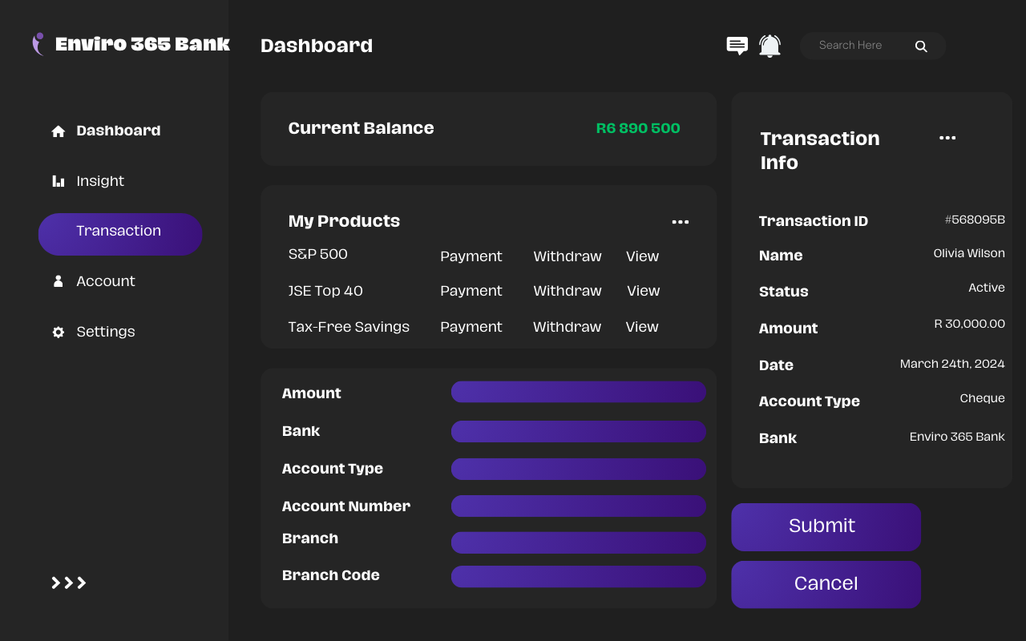

Scenario 4: Enviro 365 Bank Data Definitions

|  |  |  |  |
| --- | --- | --- | --- |
| **Entity name:** | CUSTOMER | | |
| **Attribute** | **Key (PK / FK)** | **Data type** | **Data size** |
| Customer ID |  | System | 9 |
| Create date (when the ‘Customer’ record was created) |  | System | 8 |
| Status (e.g. Good, Blacklisted) |  | Char | 1 |
| First name |  | Varchar | 20 |
| Last name |  | Varchar | 20 |
| Email |  | Varchar | 30 |
| Cell phone |  | Int | 10 |
| Date of birth |  | Date | 8 |
| Address line 1 |  | Varchar | 30 |
| Zip code |  | Int | 20 |
| Gender (e.g. Female, Unknown) |  | Char | 1 |

|  |  |  |  |
| --- | --- | --- | --- |
| **Entity name:** | ORDER | | |
| **Attribute** | **Key (PK / FK)** | **Data type** | **Data size** |
| Order ID |  | System | 9 |
| Create date (when the cart record was created) |  | System | 8 |
| Status (e.g. Paid, Abandoned, Dispatched) |  | Char | 1 |
| Order date (when the cart was checked out and paid) |  | Date | 8 |
| Customer ID |  | Char | 9 |
| Total pre-tax value |  | Num | 0 … 99999,99 |
| Total tax value |  | Num | 0 … 99999,99 |
| Total order value |  | Num | 0 … 99999,99 |
| Total quantity of products |  | Int | 1 … 99 |

Scenario 5: Website Service Inc

1. Role of a business analyst during the SDLC
   1. Requirement Analysis – gather all the requirements from stakeholders and document them.
   2. Design – assist by creating/contributing wireframes or process flows as to how the system is to work.
   3. Building – work hand in hand with Developers to ensure the right product is built.
   4. Testing – be available to assist in testing whether the requirements have been met.
2. Project Plan

|  |  |  |  |  |  |
| --- | --- | --- | --- | --- | --- |
| Project Name | e-Commerce Website | Project Manager | Marius Kruger |  |  |
| Start Date | 2 Weeks of acceptance of quote | End Date | 18 Weeks 4 Days | Overall Cost | R247 238 (50% payable upfront) |
|  |  |  |  |  |  |
| Task Name | Assigned To | Duration | Fee | Pre- Requirements |  |
| Requirement Analysis |  | 3 Weeks | R40 690 |  |  |
| Design |  | 1 Week | R18 100 |  |  |
| Building |  | 2 Weeks | R36 700 |  |  |
| Testing |  | 1 Week | R22 775 |  |  |
| Hardware Installation |  | 1 Week | R9 010 |  |  |
| Server H/W and OS |  |  | R59 800 |  |  |
| Installation onto server |  | 2 Days | R5 490 | Provide DSL and server space pre-installation |  |
| Catalogue data and image upload |  | 4 Weeks | R14 300 |  |  |
| Training and Handover |  | 2 Days | R10 988 |  |  |
| Post-Implementation Support |  | 4 Weeks | R33 385 |  |  |